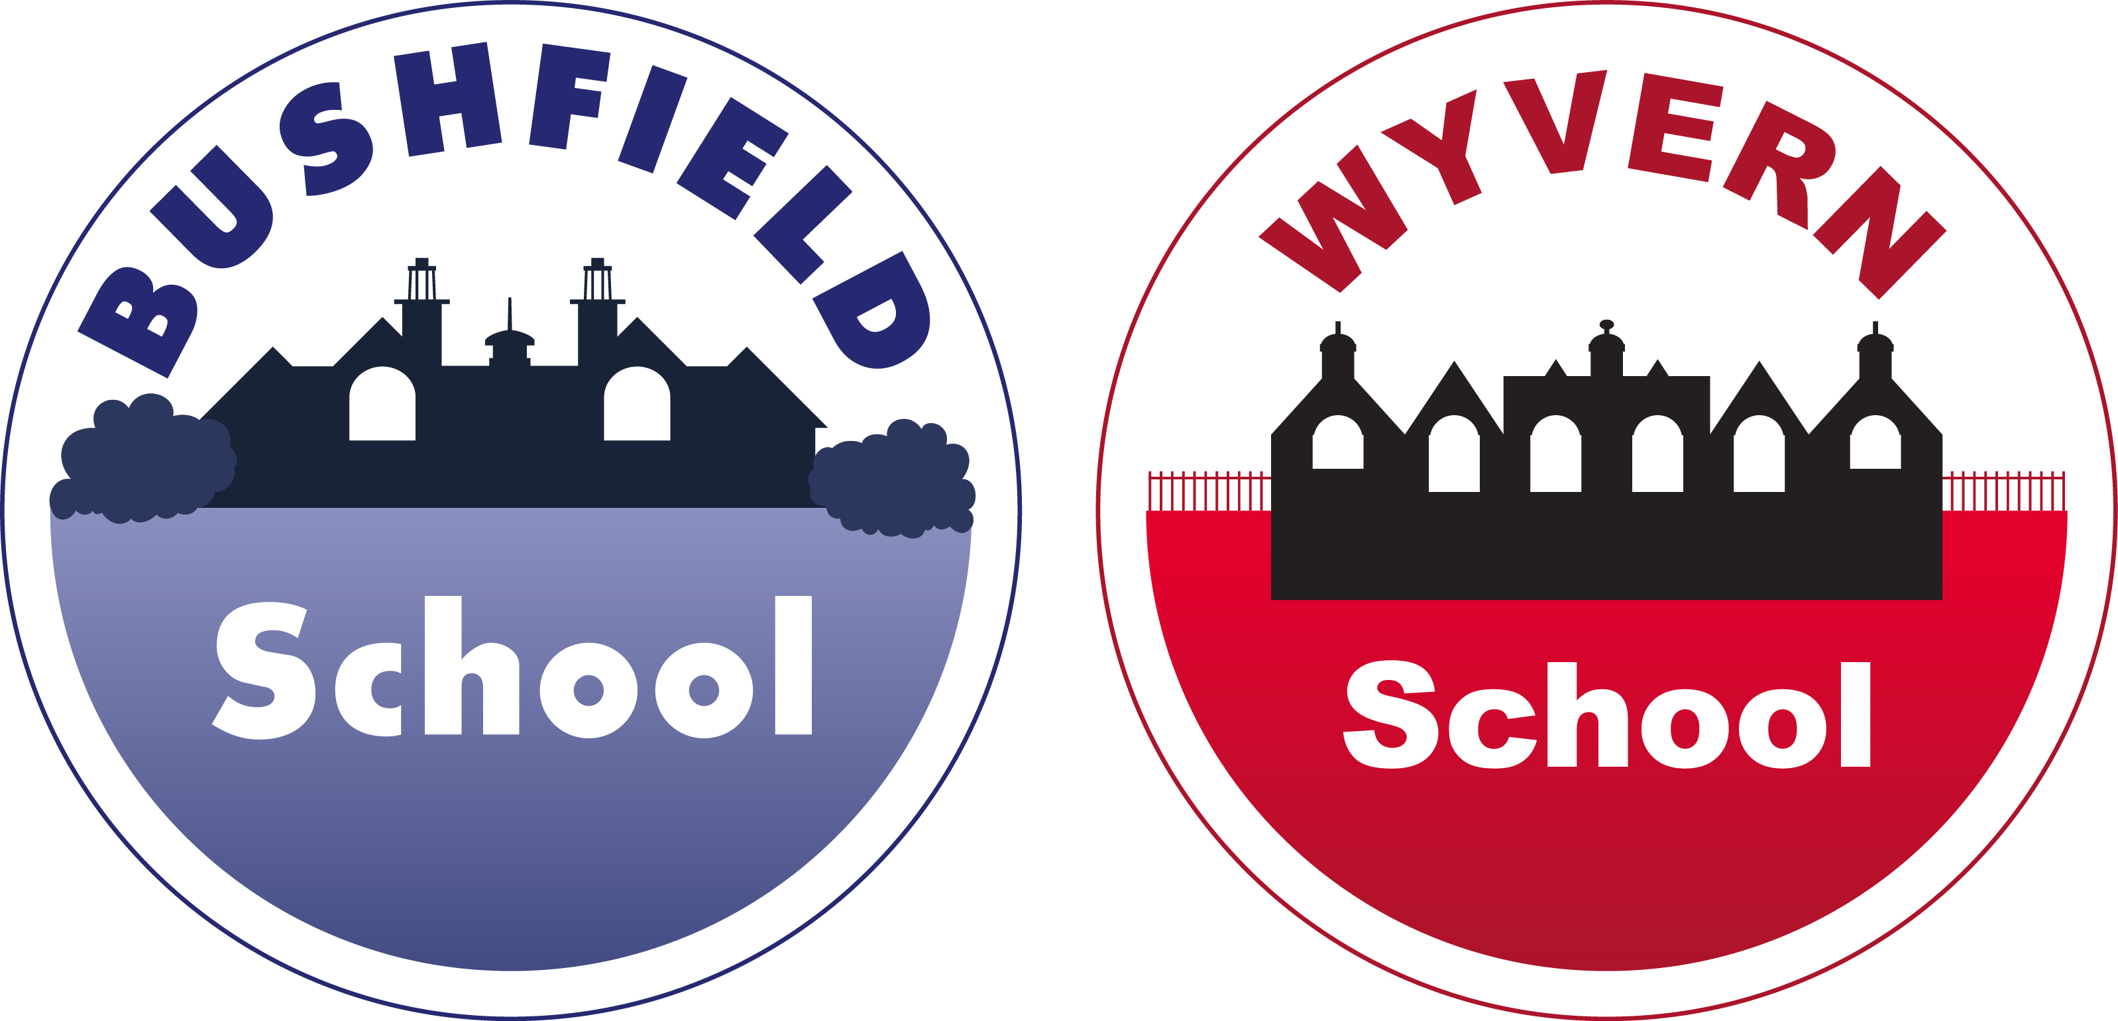

Viaduct Federation of Schools
Remote Learning Policy

Approved by: | The Governing Body | Date: Summer 2024
Next review due by: | Summer 2026

Contents
1. Aims
2. Use of remote learning 3
3. Roles and responsibilities 4
4. Who to contact 8
5. Data protection 8
6. Safeguarding 9
7. Monitoring arrangements 9
8. Links with other policies 9

1. Aims
This remote learning policy for staff aims to:
- Ensure consistency in the approach to remote learning for pupils who aren’t in school
- Set out expectations for all members of the school community with regards to remote learning
- Provide appropriate guidelines for data protection

2. Use of remote learning
All pupils should attend school, in line with our attendance policy. Remote education is not viewed as an equal alternative to attendance in school.
Pupils receiving remote education will be marked absent in line with the Pupil Registration Regulations.
We will consider providing remote education to pupils in circumstances when in-person attendance is either not possible or contrary to government guidance.
This might include:
- Occasions when we decide that opening our school is either:
  - Not possible to do safely
  - Contradictory to guidance from local or central government
- Occasions when individual pupils, for a limited duration, are unable to physically attend school but are able to continue learning, for example because:
- They have an infectious illness
- They are preparing for or recovering from some types of operation
- They are recovering from injury and attendance in school may inhibit such recovery
- Their attendance has been affected by a special educational need or disability (SEND) or a mental health issue
The school will consider providing pupils with remote education on a case-by-case basis.
In the limited circumstances when remote learning is used, we will:
- Gain mutual agreement of remote education by the school, parents/carers, pupils, and if appropriate, a relevant medical professional. If the pupil has an education, health and care (EHC) plan or social worker, the local authority (LA) will also be involved in the decision
- Put formal arrangements in place to regularly review it and identify how to reintegrate the pupil back into school
- Identify what other support and flexibilities can be put in place to help reintegrate the pupil back into school at the earliest opportunity
- Set a time limit with an aim that the pupil returns to in-person education with appropriate support
Remote education will not be used as a justification for sending pupils home due to misbehaviour. This would count as a suspension, even if the pupil is asked to access online education while suspended.

3. Roles and responsibilities
3.1 Teachers
When providing remote learning, teachers must be available during the normal school hours.
If they’re unable to work for any reason during this time, for example due to sickness or caring for a dependent, they should report this using the normal absence procedure.
When providing remote learning, teachers should:
- Provide pupils with access to remote education as soon as reasonably practicable, though in proportion to the length of absence and disruption to the learning of all learners
- Make reasonable adjustments for pupils with SEND to access remote education, where required, informed by relevant considerations including the support families will require and the types of services that pupils can access remotely
They are also responsible for:
- Setting work for children they would normally teach in school. This work should range between 1-4 hours depending on the age of the child and the reason for needing to work remotely. Work will be set by 5pm the day before it is due to completed using Teams or email with links to specific resources.
- Making sure that work provided during periods of remote education is of high quality, meaningful, ambitious and cover an appropriate range of subjects whilst considering the individual needs of pupils with additional needs.
- Providing feedback on work using Teams once it has been completed or emailed back to the school.
- Keeping in touch with pupils who aren’t in school and their parents. This should be via phone on at least a weekly basis so any questions/concerns can be raised and work discussed.
- Attending virtual meetings with staff, parents/carers and pupils following the school Dress Code and within an appropriate location to avoid noise/personal background information.
3.2 Teaching assistants
When assisting with remote learning, teaching assistants must be available during their normal working hours.
If they’re unable to work for any reason during this time, for example due to sickness or caring for a dependent, they should report this using the normal absence procedure.
When assisting with remote learning, teaching assistants are responsible for:
- Supporting pupils who aren’t in school with learning remotely –via the phone, virtual meetings or email
- Attending virtual meetings with staff, parents/carers and pupils following the school Dress Code and within an appropriate location to avoid noise/personal background information.
3.3 Subject leads
Alongside their teaching responsibilities, subject leads are responsible for:
- Considering whether any aspects of the subject curriculum need to change to accommodate remote learning
- Working with teachers teaching their subject remotely to make sure all work set is appropriate and consistent
- Working with other subject leads and senior leaders to make sure work set remotely across all subjects is appropriate and consistent, and deadlines are being set an appropriate distance away from each other
- Monitoring the remote work set by teachers in their subject – explain how they’ll do this, such as through regular meetings with teachers or by reviewing work set
- Alerting teachers to resources they can use to teach their subject remotely
- Making decisions about the use of online video lessons such as Oak National Academy
3.4 Senior leaders
Alongside any teaching responsibilities, senior leaders should continue to use the school’s digital platform for remote education provision and make sure staff continue to be trained and are confident in its use.
They should continue to overcome barriers to digital access where possible for pupils by, for example:
- Distributing school-owned laptops accompanied by a user agreement or contract (if possible)
- Securing appropriate internet connectivity solutions where possible
- Providing printed resources, such as textbooks and workbooks, to structure learning, supplemented with other forms of communication to keep pupils on track or answer questions about work
- Having systems for checking, ideally on a daily basis, whether pupils learning remotely are engaging in its use, and work with families to rapidly identify effective solutions where engagement is a concern
They are also responsible for:
- Monitoring the effectiveness of remote learning – through regular meetings with teachers and subject leaders, reviewing work set or reaching out for feedback from pupils and parents/carers
- Monitoring the security of remote learning systems, including data protection and safeguarding considerations
- Ensuring staff remain trained and confident in their use of online digital education platforms
- Training staff on relevant accessibility features that your chosen digital platform has available
- Providing information to parents/carers and pupils about remote education on our website or via email
- Working with the catering team to ensure pupils eligible for benefits-related free school meals (FSM) are provided with good quality lunch parcels or food vouchers
3.5 Designated safeguarding lead (DSL)
The DSL is responsible for:
- Upkeeping the responsibilities in our child protection policy and remote learning addendum.
3.6 IT staff
IT staff are responsible for:
- Fixing issues with systems used to set and collect work
- Helping staff and parents/carers with any technical issues they’re experiencing
- Reviewing the security of remote learning systems and flagging any data protection breaches to the data protection officer (DPO)
- Assisting pupils and parents/carers with accessing the internet or devices
3.7 Pupils and parents/carers
Staff can expect pupils learning remotely to:
- Be contactable during the school day – although consider they may not always be in front of a device the entire time
- Complete work to the deadline set by teachers
- Seek help if they need it, from teachers or teaching assistants
- Alert teachers if they’re not able to complete work
- Act in accordance with normal behaviour rules / conduct rules of the school
Staff can expect parents/carers with children learning remotely to:
- Engage with the school and support their children’s learning, and to establish a routine that reflects the normal school day as far as reasonably possible
- Make the school aware if their child is sick or otherwise can’t complete work
- Seek help from the school if they need it
- Be respectful when making any complaints or concerns known to staff
3.8 Governing board
The governing board is responsible for:
- Monitoring the school’s approach to providing remote learning to ensure education remains of as high a quality as possible
- Ensuring that staff are certain that remote learning systems are appropriately secure, for both data protection and safeguarding reasons

4. Who to contact
If staff have any questions or concerns about remote learning, they should contact the following individuals:
- Issues in setting work – talk to the relevant subject lead or SENCO
- Issues with behaviour – talk to the relevant head of year
- Issues with IT – talk to IT staff
- Issues with their own workload or wellbeing – talk to their line manager
- Concerns about data protection – talk to the data protection officer
- Concerns about safeguarding – talk to the DSL

5. Data protection
5.1 Accessing personal data
When accessing personal data for remote learning purposes, all staff members will:
- access the data, on a secure cloud service or a server in your IT network
- use provided devices, such as laptops, rather than their own personal devices
5.2 Processing personal data
Staff members may need to collect and/or share personal data as part of the remote learning system. As long as this processing is necessary for the school’s official functions, individuals won’t need to give permission for this to happen. The school will follow its data protection policy / privacy notice in terms of handling data.
However, staff are reminded to collect and/or share as little personal data as possible online, and to remind themselves of their duties in terms of data protection in accordance with the school’s policies and procedures.
5.3 Keeping devices secure
All staff members will take appropriate steps to ensure their devices remain secure. This includes, but is not limited to:
- Keeping the device password-protected – strong passwords are at least 8 characters, with a combination of upper and lower-case letters, numbers and special characters (e.g. asterisk or currency symbol)
- Ensuring the hard drive is encrypted – this means if the device is lost or stolen, no one can access the files stored on the hard drive by attaching it to a new device
- Making sure the device locks if left inactive for a period of time
- Not sharing the device among family or friends
- Installing antivirus and anti-spyware software
- Keeping operating systems up to date – always install the latest updates

6. Safeguarding
We will follow our child protection policy addendum for remote learning.

7. Monitoring arrangements
This policy will be reviewed bi-annually.

8. Links with other policies
This policy is linked to our:
- Behaviour policy
- Child protection policy and addendum to our child protection policy
- Data protection policy and privacy notices
- Home-school agreement
- ICT and internet acceptable use policy
- Online safety policy

