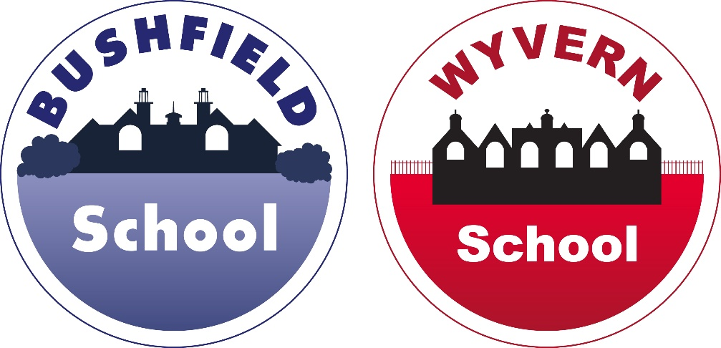

**The Viaduct Federation of Schools**

**PSHE and RSE Policy**

|  |  |  |
| --- | --- | --- |
| **Approved by:** | Full Governing Board | Summer 2024 |
| **Next review by:** | Summer 2025 | |

**Introduction**

The Government has given primary school governing boards the responsibility of considering whether or at what stage to offer Relationship and Sex Education (RSE) in primary schools. At the Viaduct Federation of Schools our governors have decided that RSE should form part of the curriculum in addition to National Curriculum Science, PSHE, PE and Computing from years 1-6 in line with the age of the pupils.

This policy has been produced in line with the statutory guidance issued by the Secretary of State in the document Relationships education, relationships and sex education (RSE) and Health education statutory Guidance, DfE September 2020. The policy is updated and reviewed annually, taking into consideration the views of parents, staff and children, and is approved by the Viaduct Federation Governing Board.

**Definition**

At the Viaduct Federation of Schools, relationship education refers to laying the foundations for lifelong learning about physical, moral and emotional development. It is about the understanding of the importance of commitment, stable relationships (both family and personal), responsibility respect, love and care as well as health, healthy lifestyles and keeping safe online. Relationships and Sex Education specifically deals with the teaching of personal hygiene, feelings and emotions, the law; sexual reproduction and how a baby is conceived, grows and is born. Physical changes to the body (puberty) is taught as part of our science curriculum.

**Aims**

* To provide a supportive learning environment in which pupils can develop their feelings of self-worth and confidence
* To promote respect and responsibility for self and in relationships with others
* To provide information which will enable pupils to gain an understanding about the development of their own and other people’s bodies
* To develop pupils’ knowledge and understanding in order that they stay safe and healthy
* Promote an environment of care and trust which enables pupils to develop their own opinions and values

**Curriculum**

Many elements of RSE are taught by class teachers, as an integral part of our Science, PSHE, PE and Computing curriculum and through our pastoral care (also see our behaviour and anti-bullying policies). We identify the following strands:

* Families and people who care for me
* Caring friendships
* Respectful relationships
* Online relationships
* Being safe
* Mental wellbeing
* Healthy eating, health and prevention
* Physical health and fitness
* Changing adolescent body
* Drugs, alcohol and tobacco

Year 1

* Families and people who care for me (PSHE)
* Caring friendships (PSHE)
* Respectful relationships (PSHE) (PE – Multi skills)
* Online relationships (PSHE) (Computing)
* Being safe (PSHE) (Computing)
* Mental wellbeing (PSHE)
* Healthy eating, health & prevention (PSHE) (Computing)
* Physical health & fitness (PSHE) (Science – Animals including humans) (PE – OAA)

Year 2

* Families and people who care for me (PSHE)
* Caring friendships (PSHE) (Computing)
* Respectful relationships (PSHE) (PE – OAA)
* Online relationships (PSHE) (Computing)
* Being safe (PSHE) (Computing)
* Mental wellbeing (PSHE)
* Healthy eating, health & prevention (PSHE)
* Physical health & fitness (PSHE) (Science – Animals including humans) (PE – OAA & Health related fitness
* Changing body (PSHE)
* Drugs, alcohol & tobacco (PSHE)

Year 3

* Families and people who care for me (PSHE)
* Caring friendships (PSHE)
* Respectful relationships (PSHE) (Computing – E-safety: Share with care) (PE – Invasion games, Dance and OAA)
* Online relationships (PSHE) (Computing – E-safety Share with care)
* Being safe (PSHE) (Computing – E-safety Share with care)
* Mental wellbeing (PSHE) (Computing – E-safety: Share with care)
* Healthy eating, health & prevention (PSHE) (PE – Health related fitness)
* Physical health & fitness (PSHE) (Science – Animals including humans) (PE – Health related fitness)

Year 4

* Families and people who care for me (PSHE)
* Caring friendships (PSHE)
* Online relationships (PSHE) (Computing E-safety Don’t fall for fake)
* Being safe (PSHE) (Computing E-safety Don’t fall for fake)
* Mental wellbeing (PSHE) (Computing E-safety Don’t fall for fake)
* Health eating, health & prevention (PSHE) (Science – Animals including humans (PE – Health related fitness)
* Physical health and fitness (PSHE) (Science – Animals including humans) (PE – Health related fitness)

Year 5

* Families and people who care for me (PSHE)
* Caring friendships (PSHE)
* Respectful relationships (PSHE) (Computing E-safety Secure your secrets & When in doubt talk it out) (PE – Invasion games, Dance & OAA)
* Online relationships (PSHE) (Computing E-safety Secure your secrets & When in doubt talk it out)
* Being safe (PSHE) (Computing E-safety Secure your secrets & When in doubt talk it out)
* Mental wellbeing (PSHE) (Computing E-safety Secure your secrets & When in doubt talk it out
* Healthy eating, health & prevention (PSHE) (PE – Health related fitness)
* Physical health and fitness (PSHE) (Science – Animals including humans) (PE – Health related fitness)
* Changing adolescent body (Science) (Science – Animals including humans) (PE – Health related fitness)*(taught at the same point as RSHE)
* Physical Reproduction (RSHE) (Science – lifecycles)
* Drugs, alcohol and tobacco (PSHE) (PE – Health related fitness)

Year 6

* Families and people who care for me (PSHE)
* Respectful relationships (PSHE) (Computing E-safety It’s cool to be kind) (PE – Invasion games, Dance & OAA)
* Online relationships (PSHE) (Computing E-safety It’s cool to be kind)
* Being safe (PSHE) (Computing E-safety It’s cool to be kind)
* Mental wellbeing (PSHE) (Computing E-safety It’s cool to be kind)
* Healthy eating, health & prevention (PSHE) (Science – Animals including humans) (PE – Health related fitness)
* Physical health and fitness (PSHE) (Science – Animals including humans) (PE – Health related fitness)
* Changing adolescent body (Science) (PE – Health related fitness)(taught at the same point as RSHE
* Consent, body shaming, unsolicited messages, peer pressure & inappropriate behaviour (PSHE/RSHE)

**Skills**

Across the curriculum content children will be encouraged to develop interpersonal skills that support the knowledge and understanding being delivered. They include (but are not exhaustive):

* Dealing with feelings and emotions
* Developing positive relationships
* Coping with physical and emotional change
* Making decisions and choices
* Personal safety
* Assertiveness
* Feeling good about oneself
* Communication
* Able to ask for help and support

The RSHE curriculum is also underpinned and linked with ‘Protective Behaviours’ (PBs). ‘Protective Behaviours is a practical and down to earth approach to personal safety which has two themes:

Theme 1 *‘We all have the right to feel safe all the time’*

This theme looks at the connection between rights and responsibilities. The difference between having a responsibility for ourselves and to others is examined. We identify for the difference between feeling safe, fun to feel scared (adventurousness), risking on purpose (which may not feel like fun but we still have choice) and feeling unsafe. These differences are manifested by what we call our ‘Early Warning Signs’ (EWS), specific bodily responses which tell us when we do not feel safe. It is these universal body signs which mean that Protective Behaviours is accessible to all people, irrespective of age, gender, nationality and ability or belief system.

Theme 2 *‘There is nothing so awful we can’t talk about it with someone’*

This theme is also explored in detail. In particular we focus on the ideas and effects of ‘talking’, and what might happen if we do not believe in this theme. We encourage everyone to develop their personal networks of support. Those people to whom they could turn if in need. Desired qualities of network people are identified and we examine how we would know if someone has these qualities. Types of networks and ways of letting people know we need to talk with them are also explored.

The RSHE curriculum content will be delivered by a pupil’s class teacher as part of their normal curriculum coverage. The specific Relationship and Sex Education content will be delivered in Year 5 and 6 only. This will be in specific standalone lessons delivered by their class teacher or an appropriate member of existing staff and may be taught in single sex groups where deemed appropriate. All RSHE lessons will consider materials and appropriate accessibility for SEND/EAL children. Where appropriate, the school may delivery sessions to smaller / discrete groups if needed.

**Resources**

Materials used in the school will be appropriate to the age and the religious and cultural background of the pupils concerned. Any SEND needs would be fully considered and catered for by the teachers delivering the sessions. If required, the Inclusion Manager would consult about the sessions with parents.

Outside agencies, if used, will be asked to submit lesson plans and material beforehand to enable staff to monitor suitability of material.

**Moral Framework for Sex Education**

We feel that it is important to try to provide all the pupils with the knowledge and skills they require to make considered, personal choices. Pupils will be taught how to resist being forced into situations by for example, peer pressure. They should be helped to consider the importance of self-restraint, dignity, respect for themselves and others, acceptance of responsibility, sensitivity towards the needs and views of others. Pupils will be made aware of the reasons for delaying sexual activity with regards to the law in the UK or for physical health and wellbeing.

Pupils’ question should be answered sensitively: due consideration should be given to any particular religious or cultural factors bearing on the discussion of sexual issues, and to parents’ wishes, as to the degree of explanation of the concepts and presentation to be used.

**Equality Act**

This policy is in accordance with the Equality Act 2010 which sets out that ‘schools cannot unlawfully discriminate against pupils because of their sex, race, disability, religion or belief or sexual orientation’. This policy is also in accordance with our Equal Opportunities, Anti-Bullying, behaviour and Child Protection Policies.

This policy also will refer to the ‘Gender questioning children’ guidance dec 2023 to ensure the school is following the set appropriate guidance.

**‘Family’ in RSHE**

Our pupils will come from many different home settings and have differing experiences of what it means to be part of a family.

Pupils may live in a traditional family consisting of a mother and father but equally their family may involve step-relationships, same sex relationships, adoption, being in care or living with a wider family. We do make it known to pupils that same-sex relationships exist, and that all the same values apply as to heterosexual relationships (e.g. respect, commitment, fidelity). We believe this is an age-appropriate way to address the topic, without promoting or stigmatising.

We would wish from the outset of any work to talk about ‘our homes’ and ‘our families’ rather than ‘our mothers and fathers’, and to build an understanding that all experiences are accepted and understood. We also aim to incorporate work which allows the pupils to learn about family traditions from other cultures.

**Questions raised by pupils**

We seek to promote enquiring minds at The Viaduct Federation of Schools, and so should not be surprised that there will be questions in these lessons. We recognise, also, that given the topic, some questions will be of a mischievous nature, while others may come from genuine personal concerns. Staff will be made aware to handle questions in an appropriate way for the individual and group and will establish a ‘safe environment’ for discussion which sets ground rules based upon trust and respect.

In the ‘safe environment’

* No personal questions will be asked of pupils or staff
* Clear, respectful and accurate language (including scientific terminology) is used in discussions (language which confuses, mystifies or offends is not helpful)
* Personal revelations are avoided
* Discussion is summarised at regular points to help keep to task
* All discussions will be without judgement or prejudice

Depending on the maturity of the pupils, it may be appropriate to discuss something further with a small group at a later time. Pupils should be encouraged to explore their feelings and feel that they can discuss them openly in a pastoral setting. Staff will refer pupils to their parents when they judge that genuine curiosity is going beyond the school’s curriculum.

**Information for Parents/Carers**

The policy is freely available to parents/carers. Parents/Carers will be informed in writing before any Relationship and Sex Education is given and invited to an information evening where the curriculum content is clearly explained. At the point of review, feedback from these evenings will be considered.

The Relationships education, relationships and sex education (RSE) and health education 2020, gives parents the right to withdraw their child from any or all parts of a school’s Relationship and Sex education curriculum at a primary school level, **but not** those elements which are required by the National Curriculum and Relationships education and health education. This parental right of withdrawal extends to all pupils attending maintained schools, including those over compulsory school age.

If any child is withdrawn parents would be invited to voluntarily indicate their reasons, so that any misunderstandings about the nature of the Relationship and Sex education provided by the school can be resolved

The parental right of withdrawal may be exercised by either parent or by a person who has responsibility or care of the child. Parents do not have to give reasons for their decision; nor do they have to indicate what other arrangements they intend to make for providing sex education for their pupils. Once a request that a child be excused has been made, that request must be complied with until the parents changes or revokes it.

**Monitoring and Evaluation**

Our SLT and curriculum Co-ordinators will monitor teaching and learning, the curriculum and its implementation according to our school’s policy. Staff feedback and pupil responses will also be monitored and used to inform policy review.